Carlos Area Fire Joint Powers Agreement (JPA) Meeting Minutes
Date: Monday, August 3th, 2026
Start Time: 6:30 PM
Location: Carlos City Hall

1. Call to Order
- Roll Call / Members Present
  - Ronna Berghoff, City of Carlos
  - Jon Trenne, City of Carlos
  - Bill Krivanek, Carlos Township
  - Dwayne Waldorf, Carlos Township
  - Andy Miller, Belle River Township
  - Colton Steidl, Carlos Fire Department, Fire Chief
  - Dustin Tomoson, Ringdahl Architects
  - Jake Steidl, Carlos Fire Department
  - Mike Swensrud, Carlos Township Resident
  - Joe Cecko, Cecko Construction Co; CMAR of the Carlos Area Firehall project
  - Jason Murray, Drown and Associates
  - Mike Diebold, Carlos Township Resident
  - Mike Maudahl, Carlos Township Resident
  - Eric Thesing, Carlos Fire Department
- Introduction of Board and those in attendance.

2. Approval of Meeting Minutes
- Review and approval of minutes from July 27th, 2026
  - Motion to approve minutes: Waldorf, seconded Trenne – Passed

3. Reports
a. Treasurer’s Report
- No Treasurers reports
4. Old Business
a. Project Discussion
- Review of bids that were submitted, Cecko Construction has opened, reviewed and organized bids
- Broken into many columns, base bid, with then 5 different Alternates.
- General discussion about bids that were received.
  - Work Scope #1 – Concrete, apparent low Tradesman Construction
  - Work Scope #2 – Metals, apparent low Boe Inc.
  - Work Scope #3 – Rough Carpentry, apparent low Tradesman Construction
  - Work Scope #4 – Finish Carpentry, apparent low Andrews Custom Carpentry
  - Work Scope #5 – Residential Casework, apparent low Schjenken – but not a complete bid, next would be Swedberg, waiting to hear back from Schjenken – going to go back and get bids specifically for p-lam.
  - Work Scope #6 – Insulation, apparent low M & M Insulation
  - Work Scope #7 – Doors, Frames and Hardware, apparent low Twin City Hardware
  - Work Scope #8 – Overhead Doors and Operators, apparent low Garage Door Store, but for a white door, red is a special order and it would add approximately $20,000 – discussed that white doors is fine.
  - Work Scope #9 – Gypsum System, apparent low Andrews Custom Carpentry
  - Work Scope #10 – Acoustical Ceilings, apparent low Wood Acoustics
  - Work Scope #11 – Flooring, apparent low Arnquist Flooring
  - Work Scope #12 – Painting, apparent low Henkemeyer Painting Inc.
  - Work Scope #13 – Misc. Specialties, apparent low Construction Supply
  - Work Scope #14 – Window Treatments, apparent low Cullens Carpet One on mid grade line
  - Work Scope #15 – Fire Suppression, apparent low Security Fire Sprinkler – but declined nitrogen generator
  - Work Scope #16 – Plumbing, apparent low Masters Plumbing
  - Work Scope #17 – HVAC, apparent low Ellingson Plumbing and Heating
  - Work Scope #18 – Electrical, apparent low Vinco Electric
  - Work Scope #19 – Earthwork and Site Utilities, apparent low Seph Construction
  - Work Scope #20 – Asphalt Paving – no direct bidding all in earth work
  - Work Scope #21 – Landscaping, apparent low Alex Irrigation
  - 5% owner contingency – is bonded for right away and if it is not used it gets applied to the new balance going forward.
- Base bid amount= $2,122,358.41
  - alt 1 = $96,400 = generator – Board voted No to alternate 1
  - alt 2 = $145,653.14 = asphalt - Board voted no to alternate 2
  - alt 3 = $23,440.00 = recycled bituminous - Board voted no to alternate 3
  - alt 4 = $8,720.10 = mini split – Board voted no to alternate 4
  - alt 5 = ($19,705) = spring start - Board voted no to alternate 5
- Soft cost = $217,102.95
- From Notes of CMAR, Joe Cecko:
  - None of the alternates 1-5 were accepted.
  - Alternate #3 was updated to reflect the accurate cost of $23,727.53 if accepted and Tradesmen became the low Earthwork bidder.
  - I will pursue additional bids for p-lam casework for cost savings. Currently showing low complete oak casework proposal.
  - Add of $19,542 for custom OH door color red was not accepted.
  - Changed window treatments to Cullen’s mid-range grade blinds of $2,664.86.
  - Add of $13,950 for fire protection dry system nitrogen generator was not accepted.
  - Add of $15,945 for lawn irrigation was not accepted. Owner will provide watering and maintenance.
  - A CMAR contingency is not included. Owner assumes risk in bid pricing being honored at time of contract execution.
  - Owner Soft Costs
  - Added legal fees of $20,000.
  - Revised FF & E budget from $128,00 to $66,000.
  - Jason, please provide debt service fees to be added to Total Project Cost. For presentation purposes to the public, I feel it would be good to keep total project cost under $2.7M if possible while still allowing for appropriate financial cushion.

- Jason Murray – capitalized interest included, used a number of $2,475,000, but with capitalized interest around debt impact number would be $2,700,000. Term of 20 years – look at attached.
  - 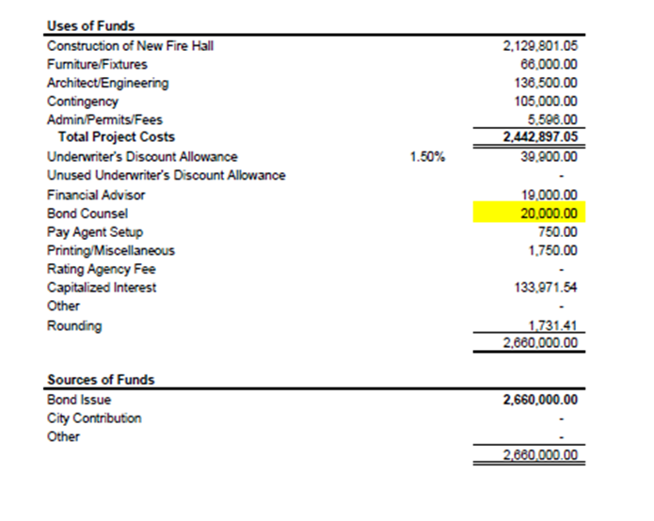
- Carlos township passed the resolution to hold special meeting on Aug 6th to review the bids and formulate the question to be placed on the November ballot.
- Dan Burns with Fryberger Law will help write and finalize the question that will be placed on the ballot for November for Carlos Township.

5. New Business
a. Building Committee
- Committee Members:
  - Mike Swendsrud – Present – added comments throughout the review of bids
  - Lawerence Keenan – Not Present
  - Fire Department Members
    - 2-3 Fireman
e. Getting information out for special election vote in November:
- Public information meeting (monthly or just Mid-October)
- Carlos Township meeting will be sending out a newsletter and explaining the project (Sept)
- Schedule meeting with a one on one interview with Echo Press or letter to Editor
- Open line

6. Miscellaneous
a. Discussion on how to inform our residents about the project to make a fully educated decision. – discussion just above.

7. Next Meeting Date and Time
- Confirm: August 10th, 2026 – 6:30 PM at Carlos City Hall
- Preliminary Agenda Items:
  - How to inform the public about the project
8. Adjournment
- Motion to adjourn: Waldorf, second Berghoff – passed.
- Adjournment time recorded: 9:02 pm
- Notes completed by: Ronna Berghoff, Carlos Area Fire JPA, Secretary; City of Carlos, Mayor

JPA BOARD CONTACT INFORMATION:
Dwayne Waldorf - Dwayne.waldorf@icloud.com; (320) 219-0409
Andy Miller - andysautorepair1@gmail.com; (320) 815-4142
Colten Steidl – cfd1251@gmail.com; (320) 766-0183
Bill Krivanek - bkrivanek1961@gmail.com; (320) 815-9751
Ronna Berghoff – rberghoff@cityofcarlos.com; (320) 491-1892
Jon Trenne – jtrenne@cityofcarlos.com; (320) 491-2126

